9TH FAI WORLD
PARAGLIDING ACCURACY
CHAMPIONSHIP
5-15 MAY 2017
VLORA, ALBANIA

INVITATION

Dear:
Albanina Air Sports Federation, invite you to participate at 9th FAI WORLD PARAGLIDING ACCURACY CHAMPIONSHIP, 05-15 MAY 2017 in Vlora, ALBANIA.
All National Teams are welcomed.
You need to confirm your national team participation at our website www.paragliding.al or you can write us for every questions at info@paragliding.al
You can find the Local Regulation in the website.
Please contact us if you need permit to enter in Albania (This is for the country that need visa to travel to Albania)

With thanks and best Regards!
General Secretary of Albanian Air Sports Federation
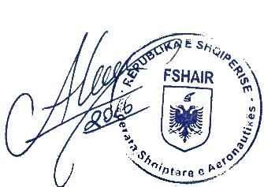
Artion Vreto Albanian AirSports Federation
Rr.Luigj Gurakuqi,
Pall 89, Shk. 2,Tirana, Albania
Tel: +355 69 20 42 222
+355 69 25 21 086
E-mail: info@paragliding.al
info@albanianairsports.com
Web: www.paragliding.al

